**Form Recogniser**

This is the **tutorial document** for using the tool Form Recongniser.

This application is used to extract text from scanned images of filled forms. The extracted text is organised in a Key-Value map and stored in json.

**General Photograph Guidelines**

* Ensure the quality of image texts should be clearly visible in sufficient brightness.
* Images should not have background texts.
* Take Photographs from the top view of the document.
* Properly clicked straight photos will result in more accurate results and reduce the effort while doing Quality Check.

Screen 1: **Processing the images**

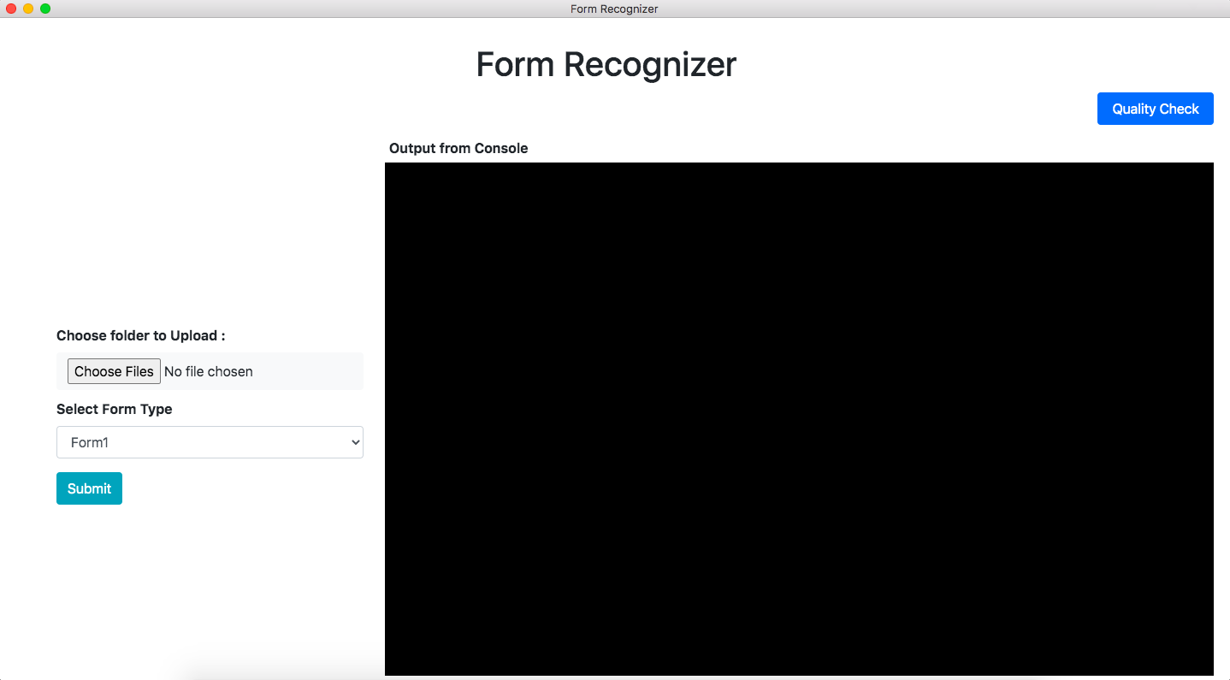

Users can select the folder which contains the raw images of the filled forms and the type of form that needs to be processed.

|  |  |
| --- | --- |
| Form 1 | Form 2 |
|  |  |

Users can process raw images by triggering the text extraction API by clicking on “**Submit**”. The script progress output will be visible on the black console area.

The script will create an **“Output”** folder within the selected folder. The output json with extracted form details & the processed image will be stored in the Output folder.

Clicking on the “**Quality Check**” button will take the user to screen 2.

Screen 2: **Checking Quality of extraction and saving to Google Cloud**

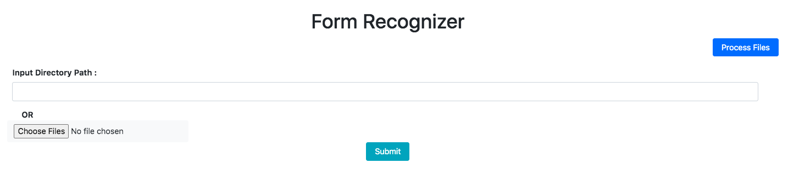

The user will be able to select the output folder in this step to verify the extracted form data. The output folder path can be pasted in the input area or choose the required folder. The “Process Files” button will take the user back to Screen 1.

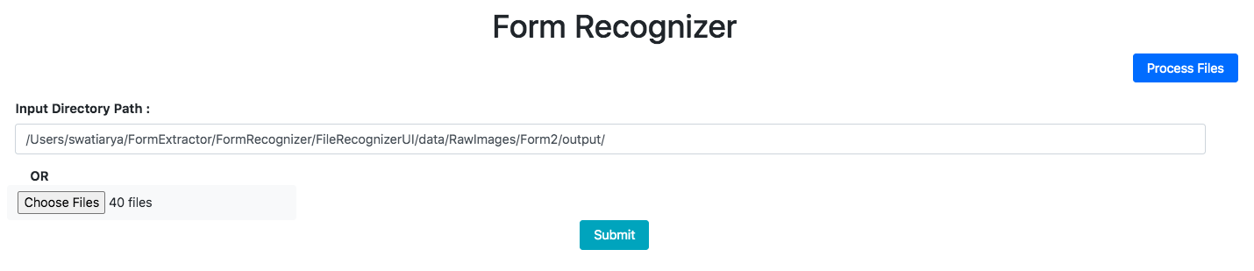

After clicking on “submit” the processed images will be displayed on the left panel.

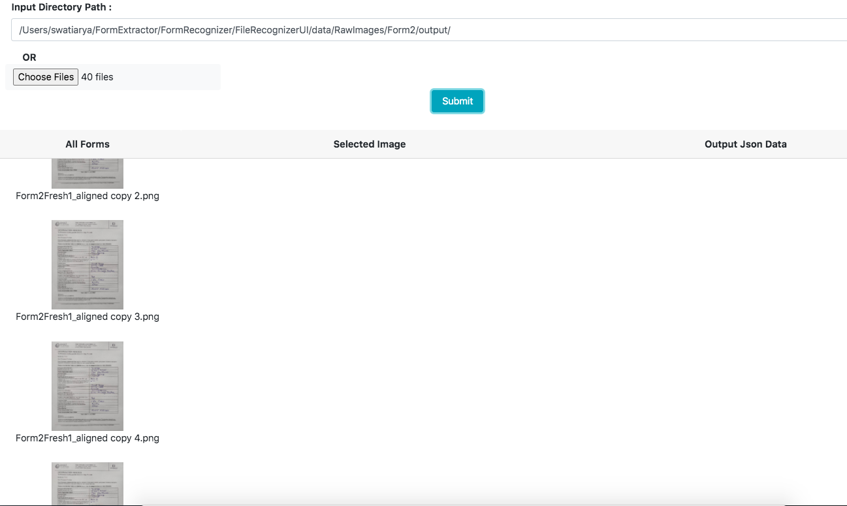

Click on any of the images will display the selected form in a larger space, and respective json with extracted form data.

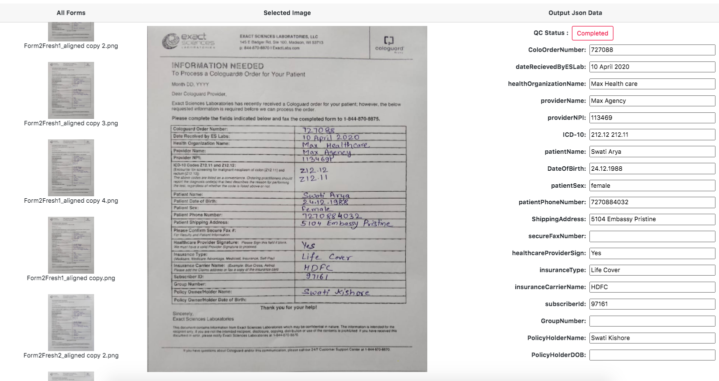

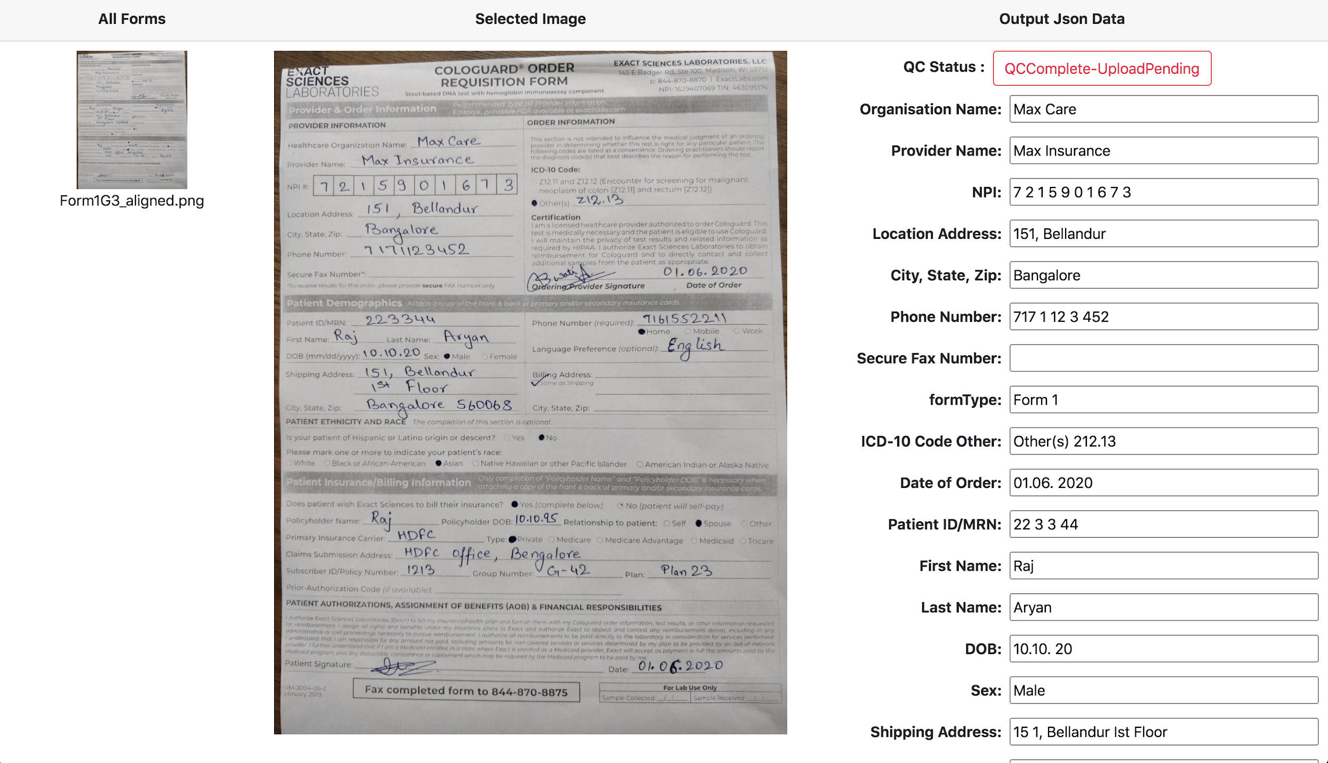

This state “QCComplete-UploadPending” comes when user clicks on submit post doing the QC but due to internet unavailability the file is not saved successfully on the google cloud. First make sure the internet is connected properly and click submit again to upload the file successfully on the google cloud.

The user can compare the actual form and extracted data, make the required corrections in the extracted text. There is a “Submit” button below the displayed form data. Clicking on the button will save the changes and store the image & json file on Google cloud store. The QC status will change “Complete” after files are saved correctly.

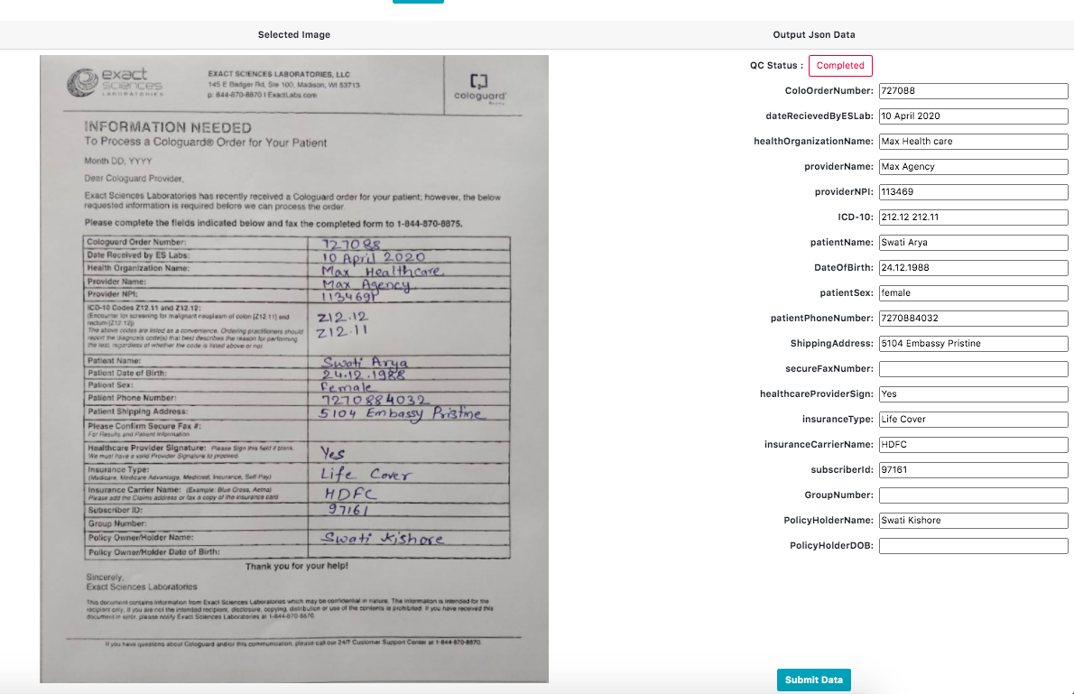

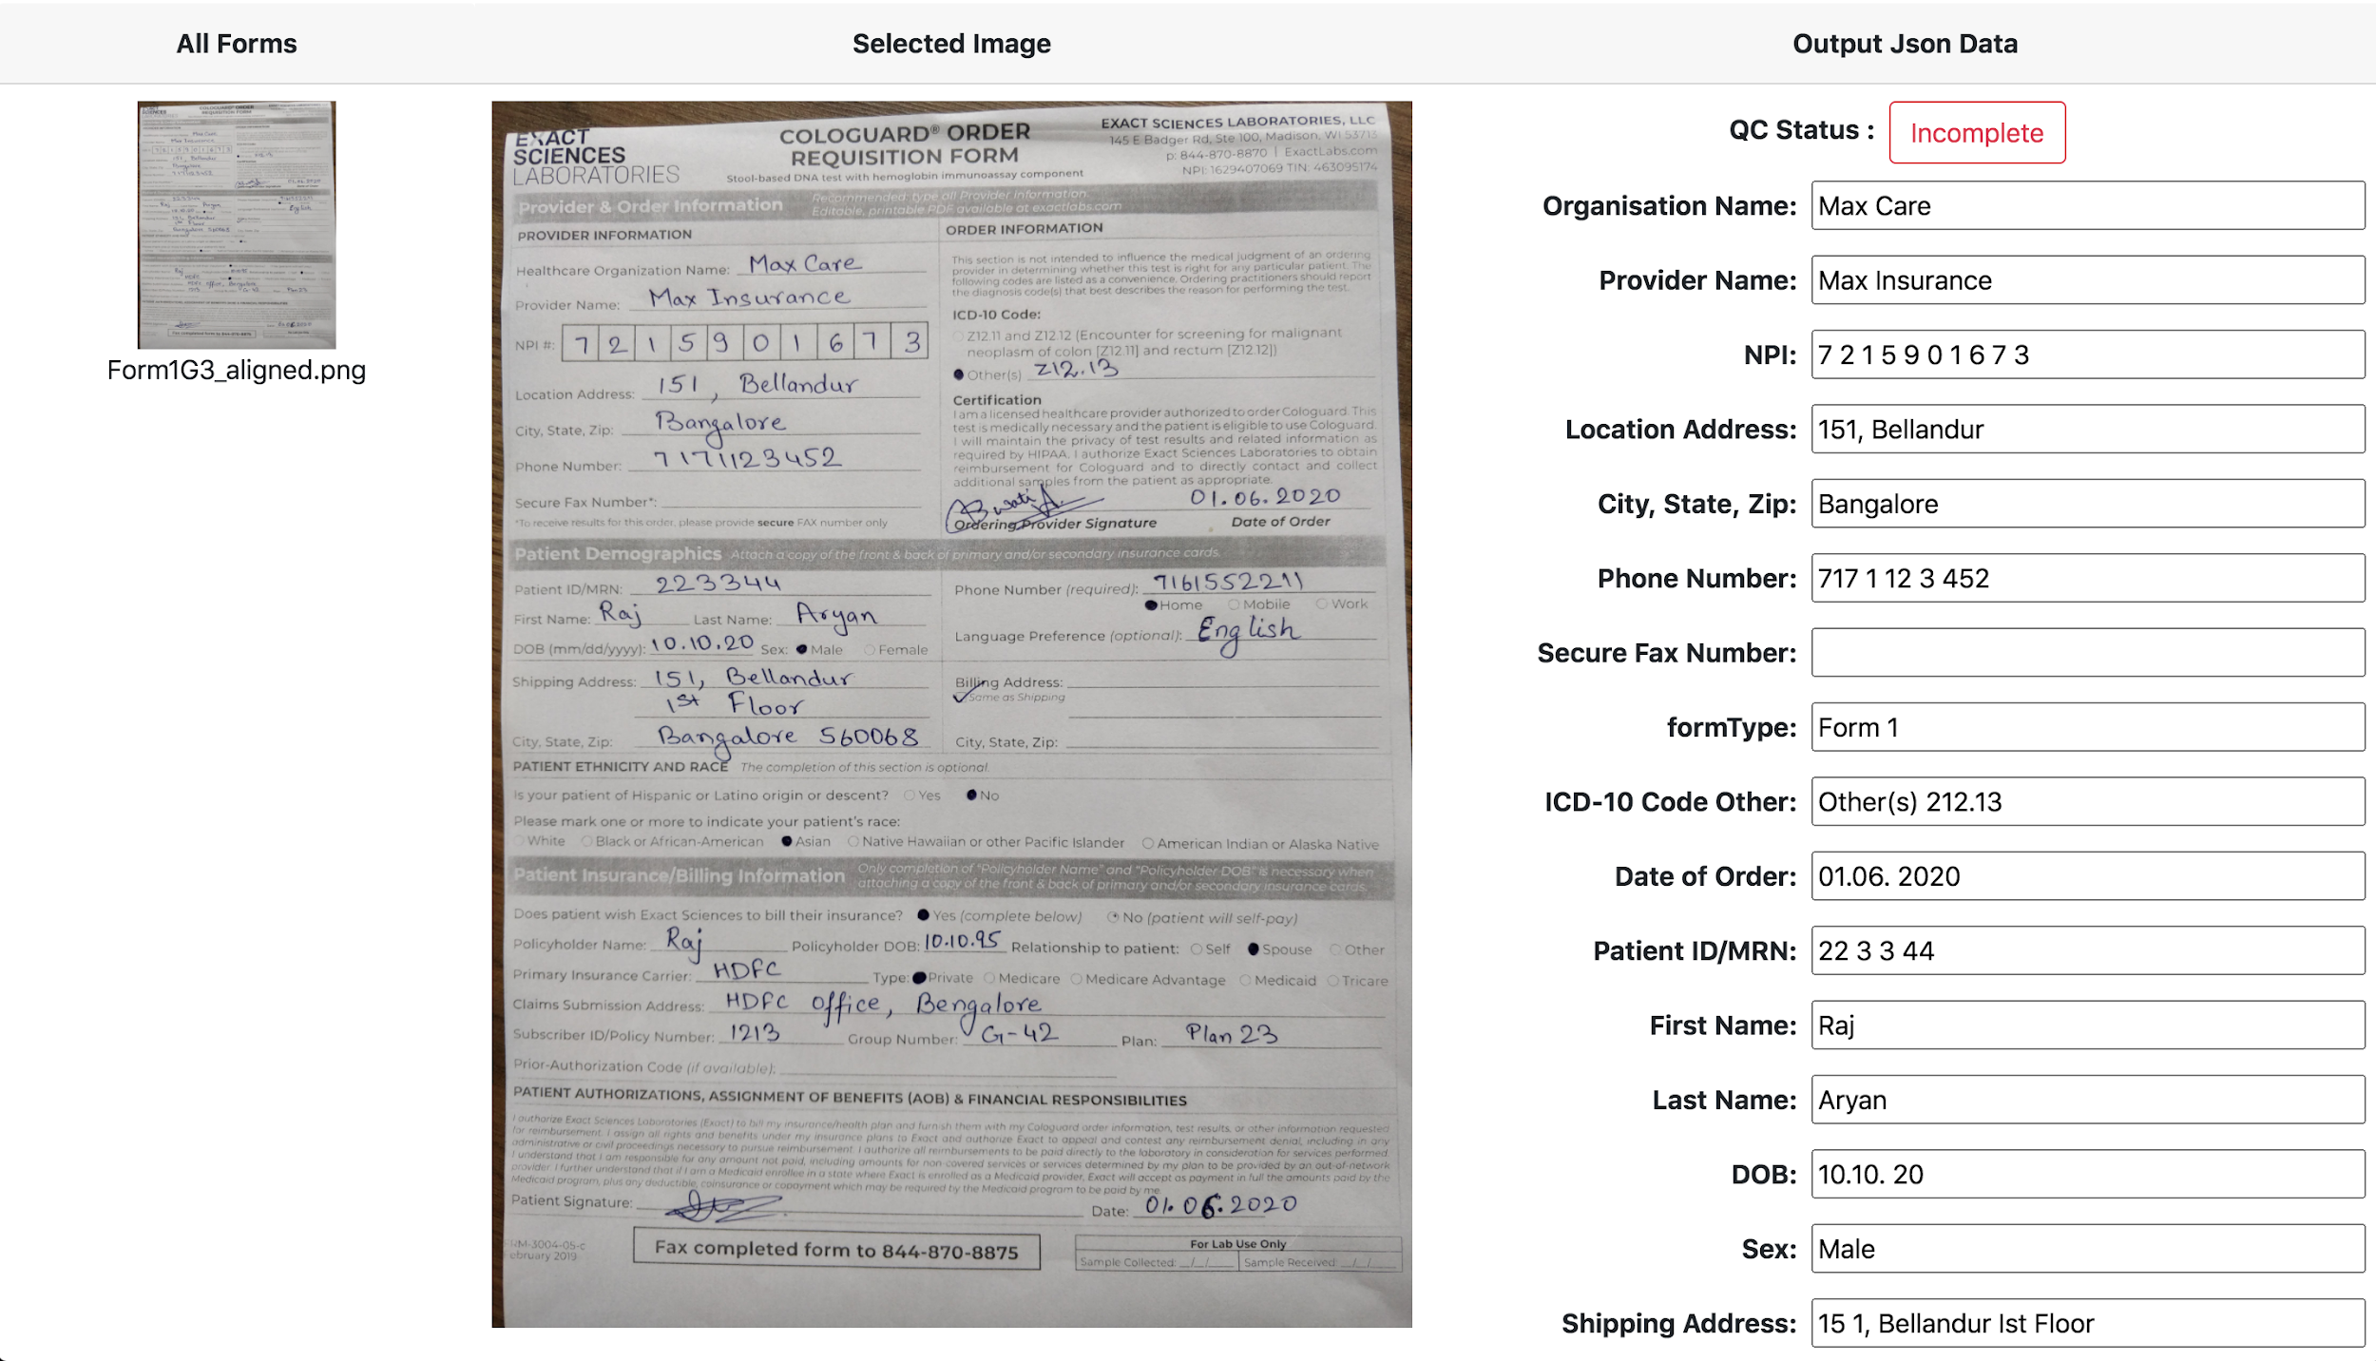

**FAQ**

1. Problem: No output is coming on the black screen.

Solution: Please check that the installation process is properly followed and python3 is correctly installed on the machine.